ELEC-3800

Random Signals and Systems

FROM: Jacob Howard

TO: Prof. Stan Reeves

DUE DATE: 3/16/22

Project 3

# **Introduction**

In this project, we ran various simulations in Matlab for testing and observation. We examined the behavior of a system where the input is random, and the output is corrupted by noise.

# **Exercise 1**

In Step 1, we were asked to Create the vectors x, n, and y in Matlab and create a scatter plot of the first 1000 points using scatter(x,y). This shows how each pair of input/output points is related. The code I created can be seen below in *Code 1* and the scatter plot is shown in *Figure 1*.

|  |
| --- |
| %% Part 1  x = rand(1000000, 1);  n = randn(1000000, 1);  y = 5*x+n;  figure(1)  scatter(x,y) |

*Code 1*

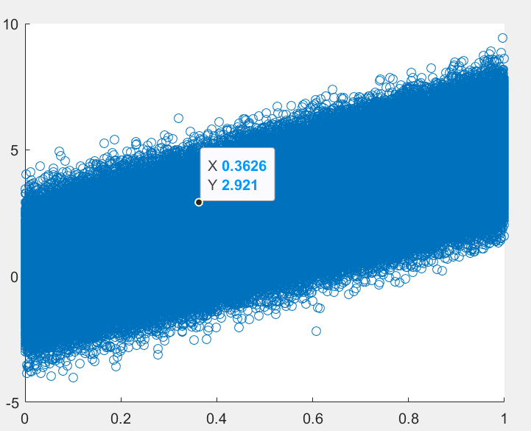

*Figure 1*

# **Exercise 2**

In part 3, we were asked to plot a 2D histogram of x and y using hist3. The code for part 2 can be seen below in Code 2, and the mesh graph can be seen in *Figure 2.*

|  |
| --- |
| %% Part 2  xc = [-0.2:0.025:1.2];  yc = [-6.5:0.2:10];  figure(2)  fxy = hist3 ([x,y],{xc yc});  mesh(xc, yc, fxy') |

*Code 2*

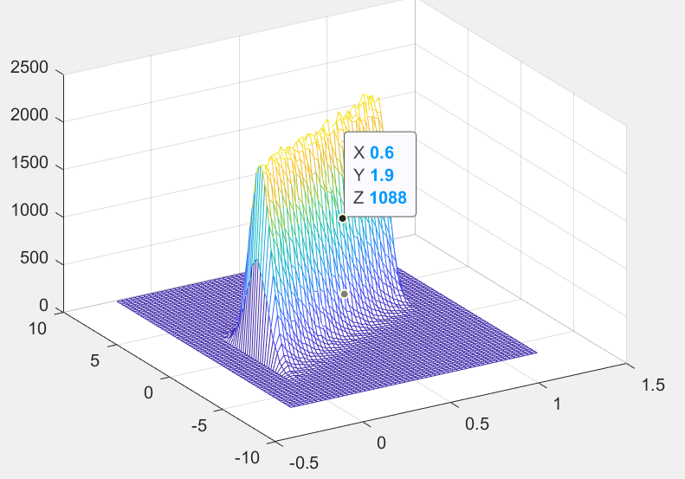

*Figure 2*

# **Exercise 3**

In task 3, we were just ask based on the plot for *Task 2:*

* What is the approximate most likely value of x if y=1?
  + *It seems that X is approaching 0.5 as Y approaches 1 based on the graph.*

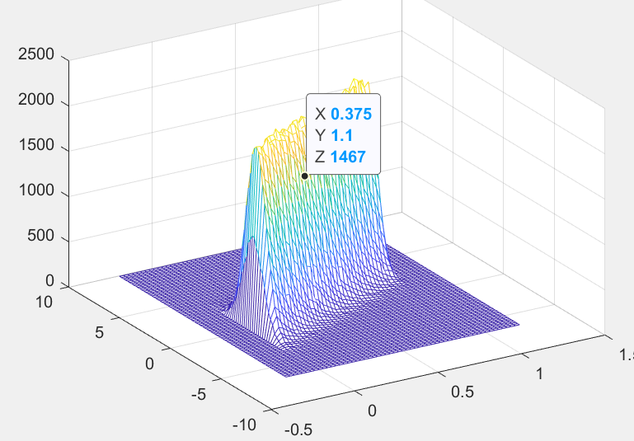

* What is the approximate most likely value of x if y=4?
  + It seems that X is approaching 1 as Y approaches 4 based on the graph.

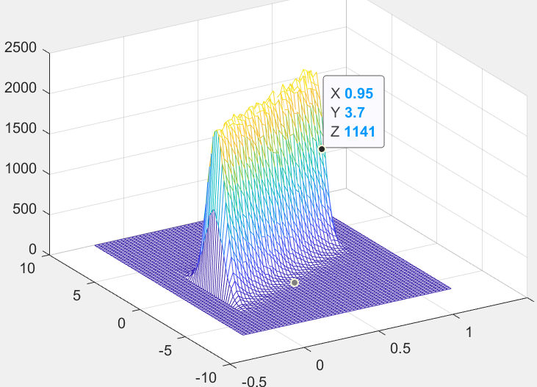

* What is the approximate most likely value of x if y=-2?
  + It seems that when Y is around -2, X is close to 0.

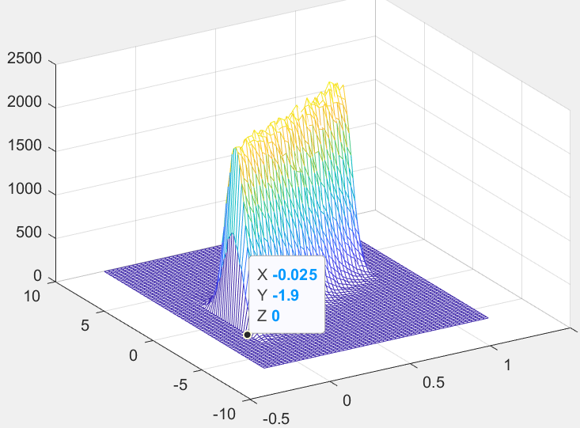

# **Exercise 4**

For part 4, we were asked to Estimate E[XY] using the formula given in Figure 3 below. We were asked to use MATLAB to multiply the elements of x with the corresponding elements of y, then find the mean of the resulting products, reported to four decimal places. The Matlab code can be seen below in Code 3. The expected value produced from the code was: **1.6652***. (Note that this expected value can vary but should be very close to the value given.)*

**

*Figure 3*

|  |
| --- |
| %% Part 4  N = 1000000;  x = rand(N,1);  n = randn(N,1);  y = 5*x + n;  sum = 0;  %loop to find product  for i=1:length(y)  sum = sum + x(i)*y(i);  end  mean = sum/length(y);  %print expected value  disp("Expected value: ");  disp(mean); |

*Code 3*

# **Exercise 5**

For the last part, we were asked to estimate the shape of the marginal density functions for x and y using “fx = hist(x,xc);”. Then we were asked to multiply the two marginal density function estimates and plot them as “mesh(xc,yc,fy'*fx)” and compare the shape of the plot to the 2D histogram and determine whether x and y are independent. The 2D and 3D graphs for part 5 can be seen in Figure 4 below. The code was given, so there is no need to provide code in the report.

* Question: Are X and Y independent?
  + From studying the graphs, I believe X and Y are independent. As Y changes, X remains the same.

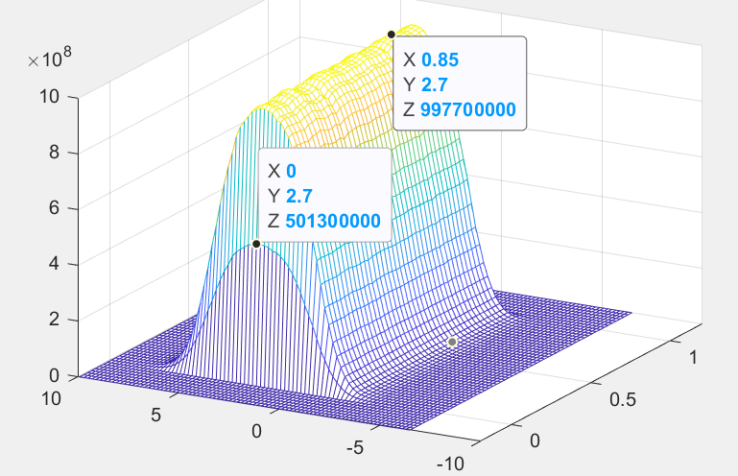

*Figure 4*

# **Conclusion**

In conclusion, this project was not too difficult. Everything was explained well, and the code was not too difficult to write. I think this project went fine and the report was written clearly. I did have some confusion with #3 on what it was asking, but I believe I eventually understood the question and gave reasonable answers.